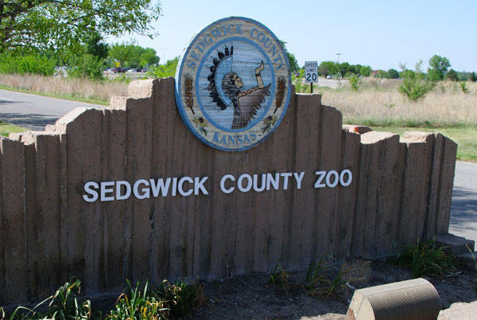

About Sedgwick Zoo Park

What is sedgwick Park Zoo? and where is located established? The Sedgwick County Zoo is a prominent zoo located in Wichita, Kansas, USA. It is one of the largest zoos in the state and is well known for its conservation efforts and diverse range of animal exhibits.

Opening & Closed Timings

Monday to Sunday: 9:00 AM - 5:00 PM

These are the typical operating hours, but they may vary during holidays or special events. The zoo is open every day of the week, although some exhibits or areas may have reduced hours during certain seasons. Holiday and Seasonal Hours.

The zoo offers various family-oriented activities, the zoo offers a Zoo Tram to help families navigate the grounds, especially for those with small children or strollers. Special Exhibits such as the African Savannah and Australia Walkabout are perfect for families to explore together Zoo Camps and Programs.

Ladies can enjoy a relaxing day or an educational outing at the zoo. The Sedgwick County Zoo has plenty of features that cater to solo visits or group outings

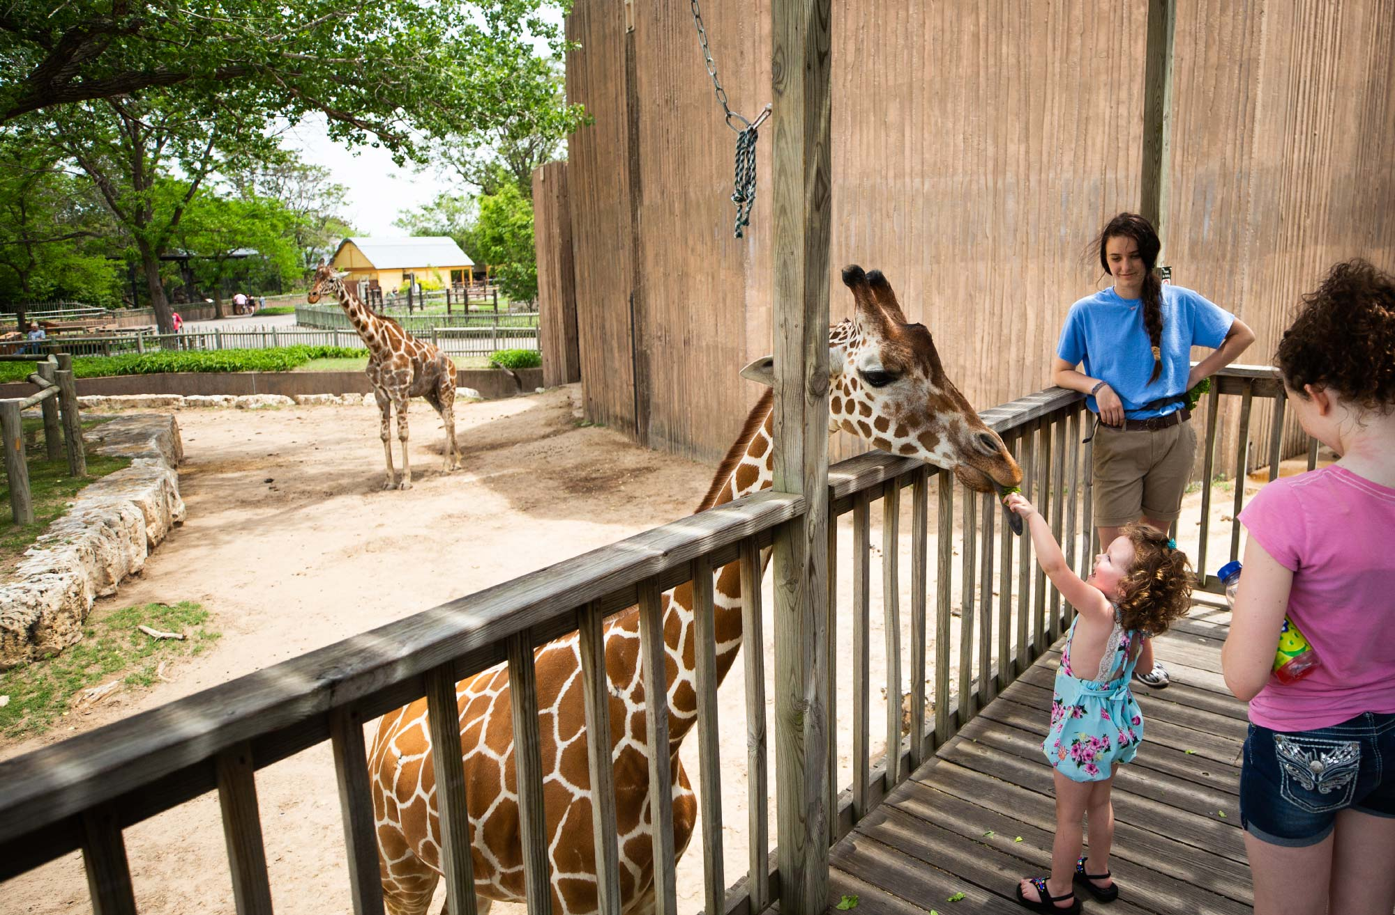

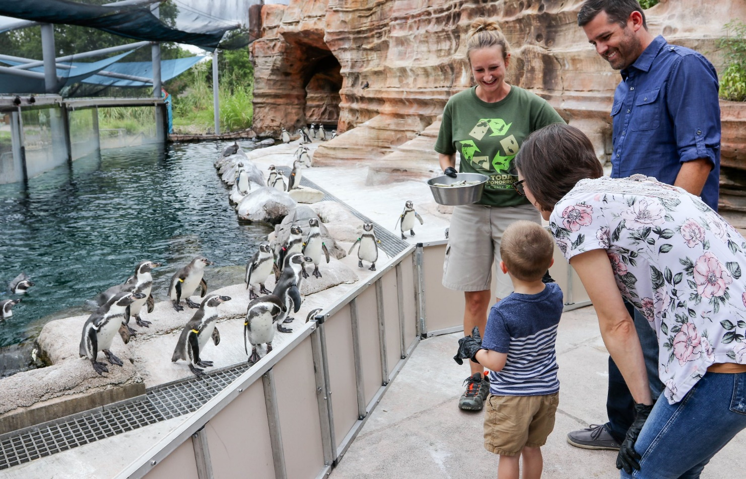

Animals List

he Sedgwick County Zoo in Wichita, Kansas, is home to more than 3,000 animals representing over 400 species.

Notable exhibits include:

Lions

Humboldt Penguin

tigers

Radiated Tortoise

Crocodiles

Reptile

Gorillas

Lizard

Giraffe

Address & Contact

Address: Sedgwick Zoo, Regent's Park, London, NW1 4RY, United Kingdom. For questions related to visiting, opening times, directions, accessibility, or other general information, you can visit their [Support Centre](https://www.scz.org).

Email: For specific enquiries

you can fill out the contact form available on their (zoo@scz.org).

Phone: For urgent enquiries, you can call their Supporter Contact team at +1 316-661-2000.

For the most accurate and up-to-date information, it's recommended to visit the [official Sedgwick Zoo website](https://www.scz.org).